Serial No Expansion:
With few changes below is the updated logic:
Hi All,
Please find the below attached SP which is called from many of the RF screens which is modified to do the below validations. Pls backup your old copy and deploy the below attached in TEST environment.
pls see the below updated new logic as part of SN expansion project
Check 0: If SN <10 digits "invlaid Serialno"
Check 1: Regardless of the length of serialno it should not be Just numeric
Check 2: Regardless of the length of serialno it should not be Just numeric
Check 3: Regardless of the length of serialno it should not be Just Alpha
Check 4: Regardless of the length of serialno it must always be alphanumeric(no special characters like : * , / , ? etc)
Check 5: Regardless of the length the first digit must starts with "S" else error "invalid serialno"[This check will be done at calling procedure/front end]
Check 6: Regardless of the length if first digit starts with "S" then remove "S"(pre-amble)
Check 7: Regardless of the length check for the duplicate serialno if not duplicate pass to Apple
Timeline:
Development until Sept 18th
Integration Testing Sept 28th - Oct 16th
UAT Testing October 19th - Nov 20th 2009
If you have any questions comments please let me know. Regional Changes done on the SQL Stored Procedure will provided to you soon.
Note: AU hub need to make changes to there existing Serial no validation logic for
1.Apple Retail Store
2.Apple Refurbish Products

RF 1 D scanning: [Tested 2009.09.23]
Check 1 – All numeric  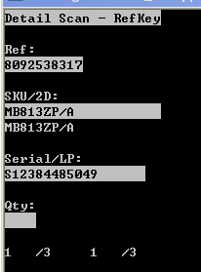 | 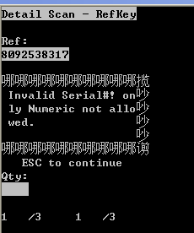
Check 2 – All alpha  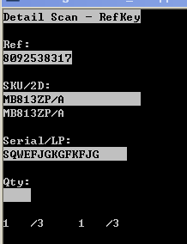 | 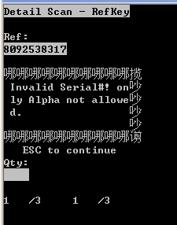

Check 2 – All alpha
Check 3 – no special characters  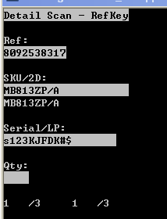 | 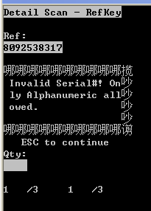
Check 4 – Invalid Pre-amble ‘S’  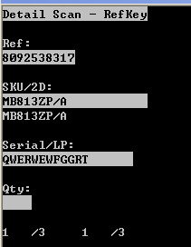 | 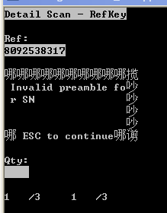
Check 5 – remove pre-amble ‘S’  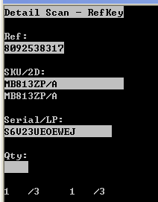 | Serial number accepted.  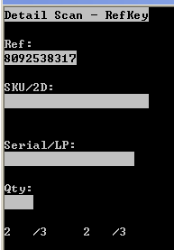
Check 6 – Duplicate SN
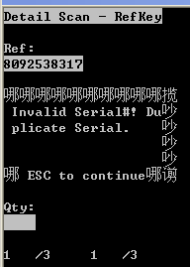
Check SG SN length > 10
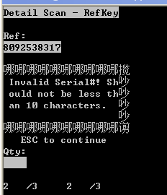

HUB – Overpack Scanning
Check 1 – All numeric
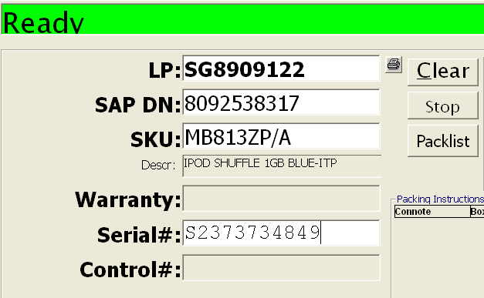
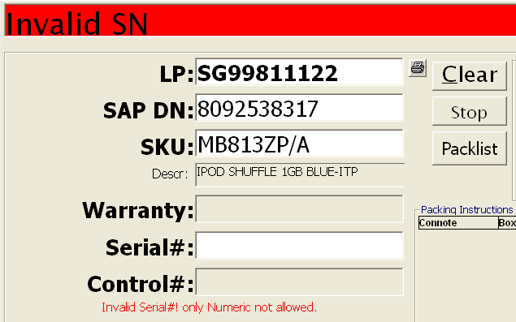
Check 2 – All alpha
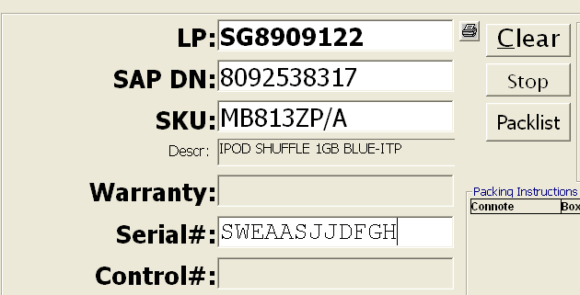
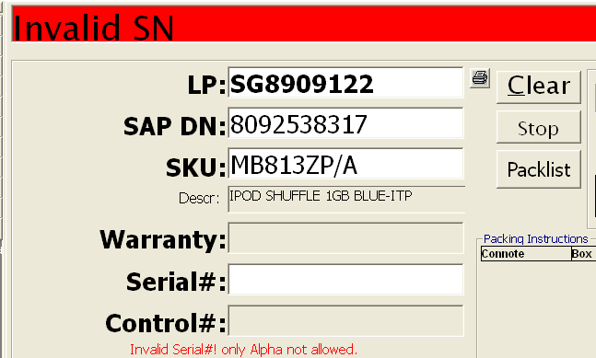

Check 3 – no special characters
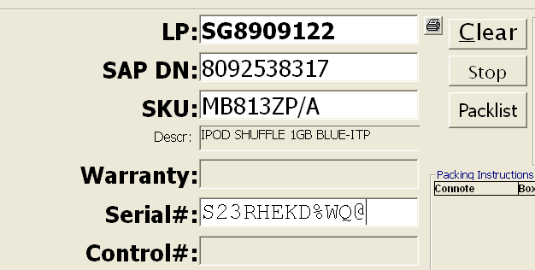
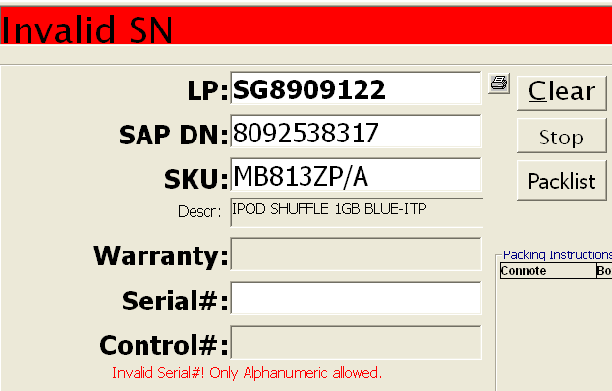
Check 4 – Invalid Pre-amble ‘S’
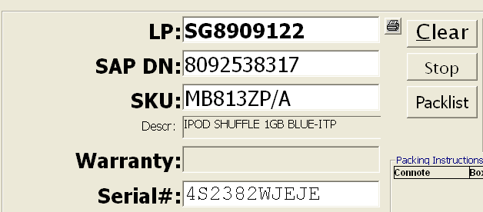
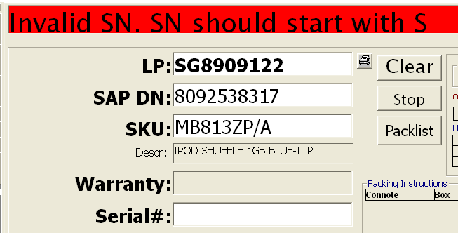

Check 5 – remove pre-amble ‘S’
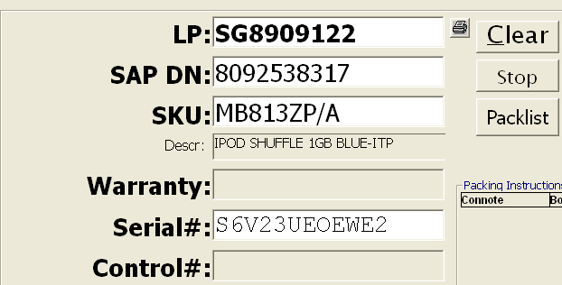
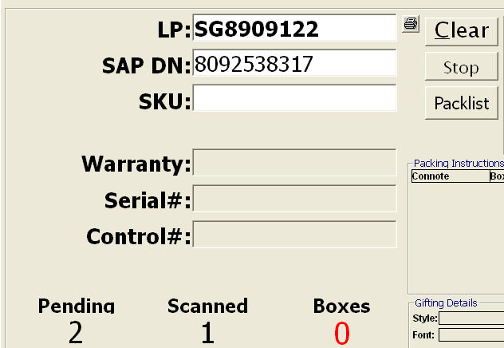

Check 6 – Duplicate SN
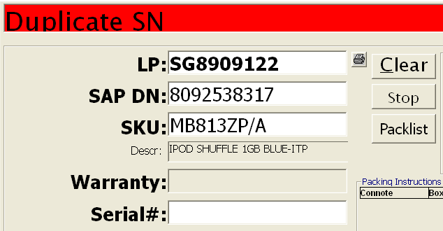
Check SG - SN length > 10
